Session 26

|  |
| --- |
| **Objectives**  The goals of this session |
| 1. Focus Activity 2 |

|  |
| --- |
| **Method Focuses**  New methods or functions that you will learn during this session |
| **N/A** |
| **Property Focuses**  Properties (variables) of classes you will learn during this session |
| No new properties |
| **Documentation Links** |
| **N/A** |

## Focus Activity 2

Based on Focus Activity 1.

Prompt: Create a basic forest that has trees in certain areas and has a basic cubic terrain with varying heights using Perlin noise.

Requirements:

1. Terrain created based on Perlin Noise
2. Trees are placed based on Perlin Noise and elevation (must be on grass)
3. Low elevation is blue, slightly higher is yellow and above is green as shown below.
4. Variable size

|  |
| --- |
| Grass (green) |
| Sand (yellow) |
| Water (blue) |

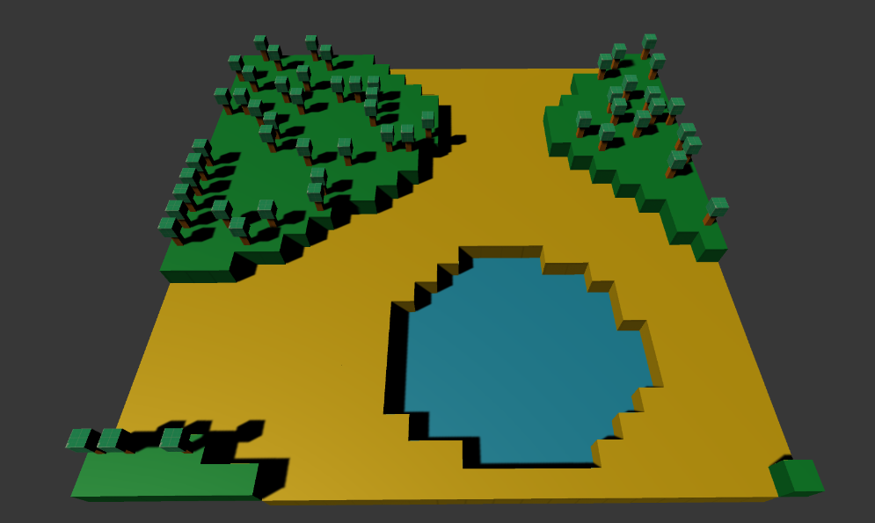

*Note in the image above the noise value of the tree was adjusted to make it more random by using the formula:

PerlinNoise *= Random.Range(0,5)

|  |  |
| --- | --- |
| **Session Information**  You can ignore this | |
| **Planned Information** | |
| Session Time Session Date | 5:00PM – 6:00PM AWST  30 March 2021 |
| **Real Information** | |
| Session Time Session Date | 5:05PM – 6:16PM AWST  30 March 2021 |
| Github Name | Session26Examples |
| Session Length | 1 Hour 11 Minutes |
| Activities Completed | |  |  | | --- | --- | | □ | Terrain generated (without colours) | | □ | Focus Activity 2 Continued | |
| Signature | ____________________________________________  *By signing this you confirm that the session has occurred and the subjects that have been taught have been allocated on this document.* |